Exam 3: NE591-10: Nuclear Fuel Performance

1. The temperature and gap width of a fuel pellet, as predicted by a fuel performance code, is shown below. Using the plots as your guide, determine what is currently occurring within the cladding, gap and/or pellet at each number. Also, describe what features in the plots indicated these behaviors. Note that the numbers are at the same burnups on the two plots. (15 pts)

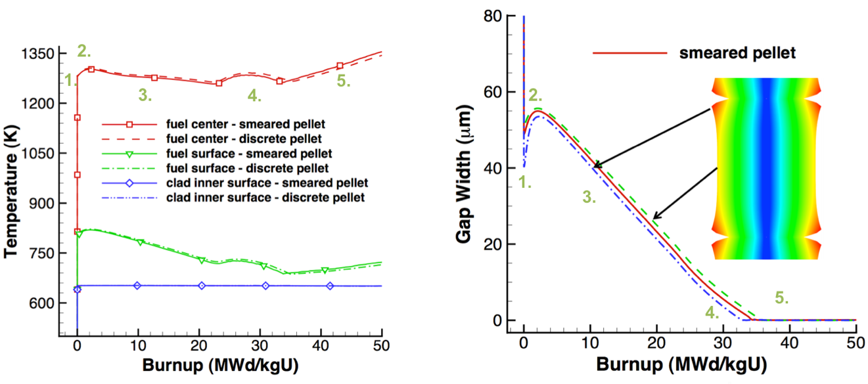

1. A ZIRLO cladding tube is in reactor at 600 K for one year. The initial wall thickness is 600 μm.
2. Estimate the oxide thickness after this time? (8 pts)
3. Assuming the hydrogen pickup fraction is 15%, what is the weight PPM of hydrogen in the cladding after one year? Assume PBR = 1.56, ρZr = 6.5 g/cc, ρZrO2 = 5.68 g/cc. (8 pts)
4. Determine the total change in the fuel volume given: αth=11x10-6, fission rate = 3.5x1013 fiss/cm3-s, T=1600 K, Tref=300 K, Δρ0=0.01, BD=5 MWD/kgU, ρ(UO2)=10.97 g/cc, t=85 days. (15 pts)
5. Zirconium creep rate question…
6. What are the five types of fission products that form in the fuel? (5 pts)
7. Name two types of creep. Which type of creep is based on bulk diffusion? (5 pts)
8. Describe the concept of microstructure-based fuel performance modeling. (6 pts)
9. List three benefits of using Zr cladding. (5 pts)
10. Why does metallic fuel undergo constituent redistribution? (5 pts)
11. MOX fuel question(s)
12. PCI question(s)
13. Larry lecture question